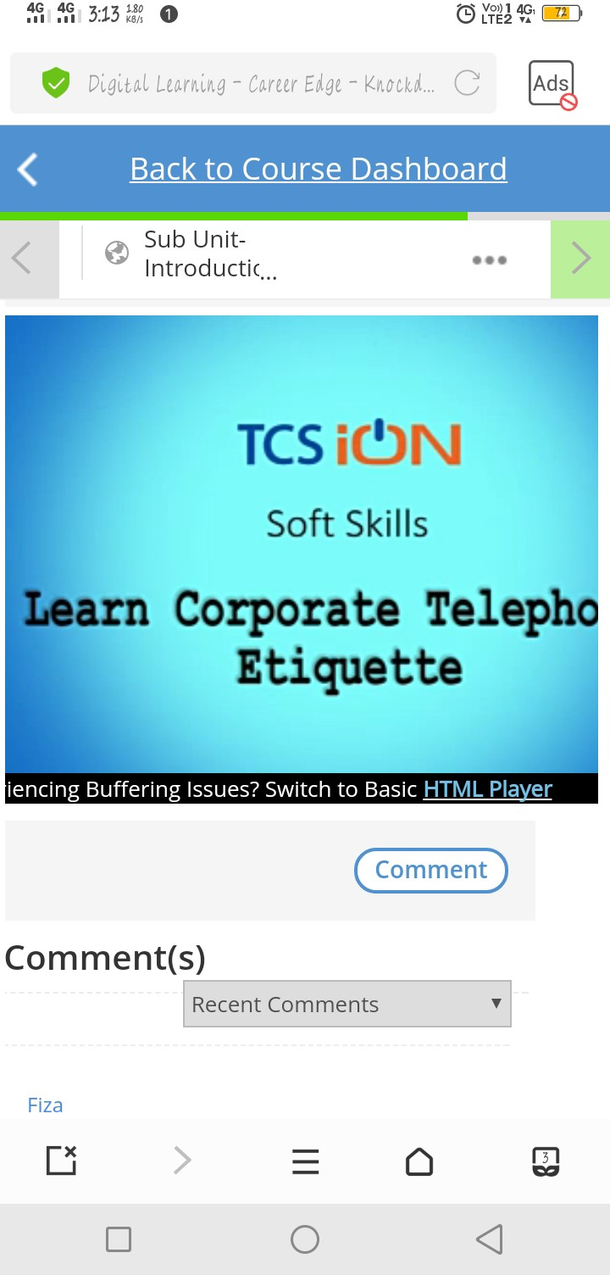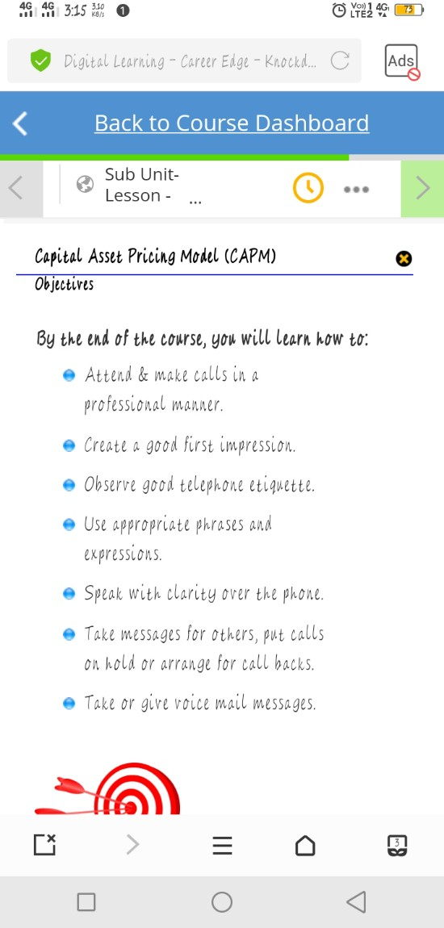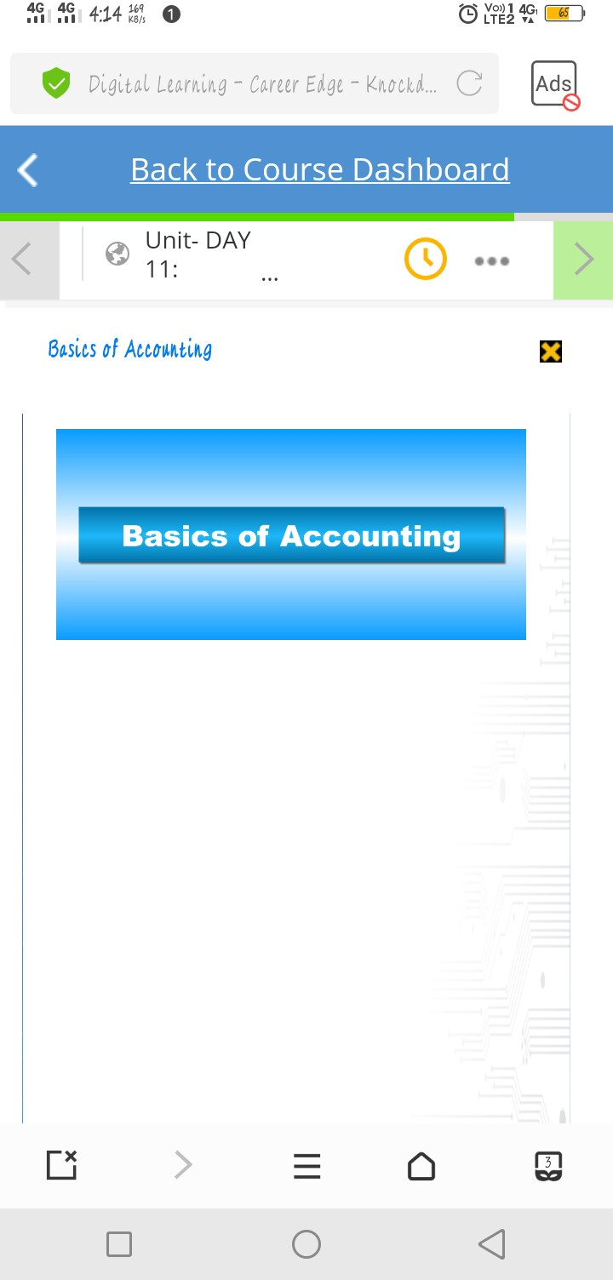***Day 4 report***

|  |  |  |  |
| --- | --- | --- | --- |
| ***Date:*** | ***21-May-2020*** | ***Name:*** | ***Srinidhi J C*** |
| ***Course:*** | ***TCS iON*** | ***USN:*** | ***4al16ec078*** |
| ***Topic:*** | ***1.Corporate telephone etiquette 2.Accounting fundamentals***  ***3.Foundation skills in IT*** | ***Semester & Section:*** | ***8th sem & B*** |
| ***Github***  ***Repository:*** | **https://github.com/alvas-education-foundation/SrinidhiJC078.git** |  |  |

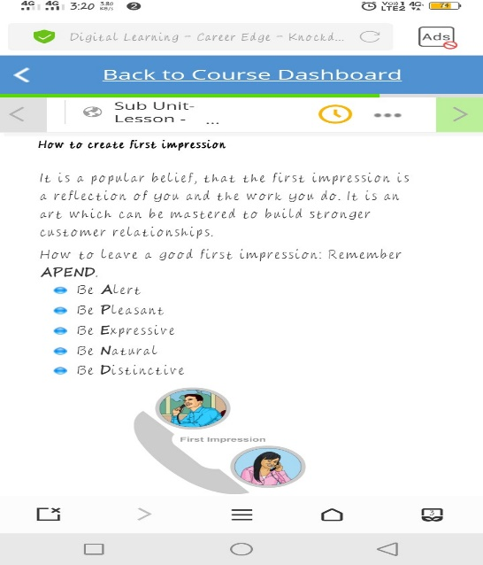

***Image of session***

***MORNING SESSION DETAILS***

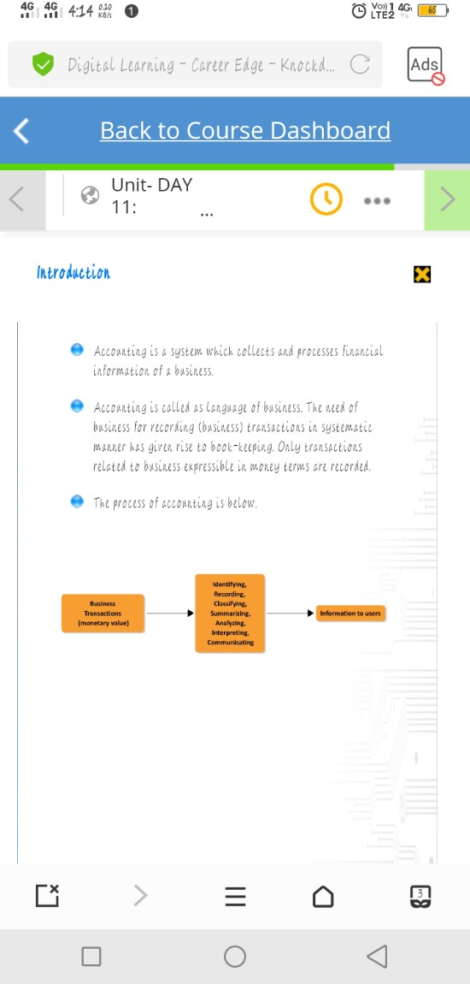

**Report of the course:**

1. ***Corporate telephoneetiquette***

**However,whenitcomestobusinessintroductions,salespitches,orthehandlingofsensitive information,nothingbeatsaphoneconversation.Evenastechnologyadvances,itisunlikely thatbusinessphonecallswillgoawayanytimesoon.Sohowdoyouensureyou’reapplying modernetiquettetothistimelessformofcommunication?Inordertoensureyouareproperly branding your company over the phone and providing exceptional customer service, we’ve assembledsomedo’sanddon’tstoguideyourcalls:**

* 1. ***Business Phone EtiquetteDo’s:***

**Introduceyourself.EvenintheageofcallerID,itcanbejarringtopickupthephoneandjump rightintoaconversation.Remindthepersonyou’recallingwhoyouareandwhyyou’rereaching out.Theywillappreciatethecourtesyeveniftheyrecognizedyournameandnumberwhenthey pickedup.**

**Speakclearly.Enunciationissoimportantwhenyoudon’thavebodylanguagecuestopickup on.Besuretospeakcarefullyandslowlysothatthepersonontheotherendofthelinecan understandyou.**

**Listentorequests.Whenyou’rebusymultitasking,itcanbehardtofocusontherequirementsof thepersononthephone.Setothertasksasideasyouactivelylistentorequestsfromthecaller. Askfollow-upquestionsforclarificationandtoshowthatyou’reengagedintheconversation. Makethekindofcallyou’dliketoreceive.TheGoldenRuleappliestojustabouteverythingin life,butthisisespeciallytrueinthebusinessworld.Treatcallersthewayyouliketobe treatedonthephone.Thatmeansmakingeasy,friendlyconversationthataccomplishesgoalsfor bothparties.**

**Leavesuccinctvoicemails.Ifyougetsomeone’svoicemail,leaveamessagethat’sshortand sweet.Includeyourcontactinformationandaquickindicatorofwhyyou’recalling**

* 1. ***Business Phone EtiquetteDon’ts:***

**Don’t answer the phone too casually in a business setting. A “Hello!” is fine but consider**

**includingyournameasyoupickupacall.Statethenameofthebusinesswhenyou’reanswering the phone,too.**

**Don’tleavepeopleonholdforalongperiodoftime.Ifyouhavetoputapersononhold,ask themifit’sokaytodoso.Attimes,itmaybebettertotakedownthecaller’snumberandask to call them back later. There’s no quicker way to make a person feel unimportant than by placing them on an extendedhold!**

**Don’t talk with your mouth full. Your mom probably warned you not to do this, and if you’re makingimportantcallsoveryourlunchhour,youmightbetemptedtochatasyouchew.Resist theurge!There’snothingworsethansomeonesmackingtheirlipsinyourear.**

**Don’t use slang. Unless you know the person on the other end of the line socially, it’s best to keep language professional. Swap out “hang on a sec” for “just a moment, please” and you’re sure to impress the person on the line – or at least not offend them with your casual vibes.**

**Don’tspeaktooloudly.Dependingonthevolumeintheroomyou’rein,youcouldbespeakingfar tooloudlywhenmakingcalls.Adjustyourvoicetoanormaltoneanddon’tbeafraidtoaskthe personyou’recallingiftheycanhearyou.Nobodylikesbeingshoutedatoverthephone.**

1. ***Accountingfundamentals***

**Accountingisthepracticeofrecordingandreportingonbusinesstransactions.Thebasicsof accountingcanbesummarizedwithinthefollowingpoints:**

**Systemofrecordkeeping.First,theremustbearationalapproachtorecordkeeping.Thismeans setting up accounts in which information is stored. Accounts fall into the following classifications:**

**Assets. These are items purchased or acquired, but not immediately consumed. Examples are accounts receivable and inventory.**

**Liabilities.Theseareobligationsofthebusiness,tobepaidatalaterdate.Examplesare accounts payable and loanspayable.**

**Equity.Thisisassetsminusliabilities,andrepresentstheownershipinterestoftheownersof the business.**

**Revenue.Thisistheamountbilledtocustomersinexchangeforthedeliveryofgoodsor provision ofservices.**

**Expenses. This is the amount of assets consumed during the measurement period. Examples are rent expense and wages expense.**

**Transactions.Theaccountantisresponsibleforproducinganumberofbusinesstransactions, whileothersareforwardedtotheaccountantfromotherpartsofthecompany.Aspartofthese transactions,theyarerecordedwithintheaccountsthatwenotedinthefirstpoint.Key transactionsare:**

**Purchase materials and services. Requires the issuance of purchase orders and the payment of supplier invoices.**

**Sell goods and services to customers. Requires the creation of an invoice to be sent to each**

**customer, documenting the amount owed by the customer.**

**Receive payments from customers. Requires matching received cash to open invoices.**

**Payemployees.Requiresthecollectionoftimeworkedinformationfromemployees,whichis thenusedtoproducegrosswageinformation,taxdeductions,andotherdeductions,resultingin net pay toemployees.**

**Reporting.Onceallofthetransactionsrelatedtoanaccountingperiodhavebeencompleted,the accountant aggregates the information stored in the accounts and reformats it into three documentsthatarecollectivelycalledthefinancialstatements.Thesestatementsare:**

**Income statement. This document presents revenues and subtracts all expenses incurred to arrive atanetprofitorlossforthereportingperiod.Itmeasurestheabilityofabusinesstoattract customers and operate in an efficientmanner.**

**Balancesheet.Thisdocumentpresentstheassets,liabilities,andequityofabusinessasofthe endofthereportingperiod.Itpresentsthefinancialpositionofanentityasofapointintime, andiscloselyreviewedtodeterminetheabilityofanorganizationtopayitsbills.**

**Statement of cash flows. This document presents the sources and uses of cash during the reportingperiod.Itisespeciallyusefulwhentheamountofnetincomeappearingontheincome statementvariesfromthenetchangeincashduringthereportingperiod.**

1. ***Foundation skills inIT***
2. ***Objective***

**The objective of the course is to train students on basic skills in IT to help enhance employabilityandmakestudentsindustry-ready.Thisinteractivecourseisdisseminated through experiential learning. The skills acquired through this course help the students prepareforemployment,andaswellorientthemtowardslife-longlearning.Thisinteractivecourseis designed by experts from large member companies—Accenture, Cognizant, HCL, Infosys, Microsoft,TCSandWipro(Mission10X.PMIhasprovidedtheProjectManagementModule.**

1. ***COURSEOUTLINE***

**Thecontentsofthiscoursearedesignedtosupportthecourseobjectives.Thefollowingfocus areasareincludedinthiscourse:**

**Section A: Technology**

**Module 1: Technology Fundamentals Module 2: RDBMS**

**Module 3: Software Development Life Cycle Module 4: Networking**

**Section B: Business Dynamics**

**Module 5: Campus to Corporate**

**Module 6: Interpersonal Effectiveness Section C: Principles of Project Management**

**Module 7: Setting up projects Module 8: Project Planning**

**Module 9: Executing and managing a project**

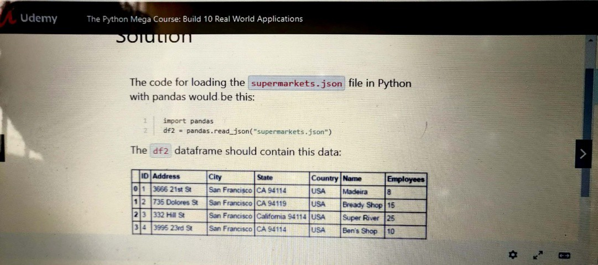

|  |  |  |  |
| --- | --- | --- | --- |
| ***Date:*** | ***21-5-2020*** | ***Name:*** | ***Srinidhi J C*** |
| ***Course:*** | ***Python programming*** | ***USN:*** | ***4AL16EC078*** |
| ***Topic:*** | 1. ***Project Exercise with Python and MySQL Interactive English*** 2. ***Dictionary Data analysis with panda*** | ***Semester & Section:*** | ***8th B*** |
| ***Github Repository:*** | **https://github.com/alvas-education-foundation/SrinidhiJC078.git** |  |  |

***Image of session***

***AFTERNOON SESSION DETAILS***

**Report –**

In today’s section I have learnt these many programs:

import json

from difflib import get_close_matches

data = json.load(open("data.json"))

def translate(w):

w = w.lower()

if w in data:

return data[w]

elif w.title() in data:

return data[w.title()]

elif w.upper() in data: #in case user enters words like USA or NATO

return data[w.upper()]

elif len(get_close_matches(w, data.keys())) > 0:

yn = input("Did you mean %s instead? Enter Y if yes, or N if no: " % get_close_matches(w, data.keys())[0])

if yn == "Y":

return data[get_close_matches(w, data.keys())[0]]

elif yn == "N":

return "The word doesn't exist. Please double check it."

else:

return "We didn't understand your entry."

else:

return "The word doesn't exist. Please double check it."

word = input("Enter word: ")

output = translate(word)

if type(output) == list:

for item in output:

print(item)

else:

print(output)

query = cursor.execute("SELECT * FROM Dictionary WHERE Expression = 'rain'")

That statement retrieved all the rows of the Dictionary table where the value of the column Expression was rain. The string inside cursor.execute() is SQL code that Python sends to the database. That kind of language is understood by the database.

Here are some more examples of SQL queries that you can try out from within your Python script just like we did previously:

* Get all rows where the value of the column Expression starts with r:

"SELECT * FROM Dictionary WHERE Expression  LIKE 'r%'"

* Get all rows where the value of the column Expression starts with rain:

"SELECT * FROM Dictionary WHERE Expression  LIKE 'rain%'"

* All rows where the length of the value of the column Expression is less than four characters:

"SELECT * FROM Dictionary WHERE length(Expression) < 4"

* All rows where the length of the value of the column Expression is four characters:

"SELECT * FROM Dictionary WHERE length(Expression) = 4"

* All rows where the length of the value of the column Expression is greater than 1 but less than 4 characters:

"SELECT * FROM Dictionary WHERE length(Expression) > 1 AND length(Expression) < 4"

* All rows of column Definition where the value of the column Expression starts with r:

"SELECT Definition FROM Dictionary WHERE Expression LIKE 'r%'"

* You can load a CSV file with this code:

import pandas

df1 = pandas.read_csv("supermarkets.csv")

Try loading the supermarkets.json file for this exercise using read_json instead of read_csv.

If you don't have the supermarkets.json, you can find it attached in this lecture.

use Nominatim() in the next video. Nominatim() currently has a bug. To fix this problem, whenever you see these lines in the next video:

from geopy.geocoders import Nominatim

nom = Nominatim()

change them to these

from geopy.geocoders import ArcGIS

nom = ArcGIS()

The rest of the code remains the same.